Intro to WebGL Lab Guide

## Overview

In this lab you will be producing a “hello world” of sorts w.r.t. real-time computer graphics: the spinning primiting (usually a cube). Behold!



By now, you probably understand that there is a lot more that goes into producing a simple image than would appear. Unfortunately, even with this expectation, the reality often exceeds it… hence this guide.

In the past when new console hardware arrived for developers to start utilizing, a somewhat joking measurement was that of how long it took them to figure out how to render the first triangle (“time to first triangle”). It was hurdle that had to be jumped because there tends be a great deal of scaffolding surrounding the basics.

Before proceeding, it is assumed that you have read through and are **familiar** with the material presented in chapter 1 & 2 of the [WebGL Programming Guide](http://uniguld.dk/wp-content/guld/DTU/webgrafik//0321902920_WebGL.pdf), the rasterization pipeline lectures, and chapter 2 of Real-time Rendering (4th edition).

## 

## About this Guide

Like everything, this guide is not perfect. If something in this guide is unclear to you or seemingly wrong, please leave a comment on the side of the page using the commenting feature of Google Docs. It should be as simple has highlighting something, right clicking, and selecting comment.

Also note, anything that is **underlined in blue is also a link**. These links will make it easy for you to access documentation in certain instances or even download the skeleton code to get started. Keep an eye out for them.

Google Docs will also mark code as being misspelled. You may want to disable spell checking (“underline errors”) in the tools menu.

## About the WebGL API

WebGL can be understood as a state machine. If you modify any of its attributes (“state”), that modification is maintained until you modify that attribute again. Let’s look at a concrete example.

Before every frame we render, we clear out the results of the previous one by calling the *clear* function on the gl context (known as the variable “gl” in our code).

gl.[clear](https://developer.mozilla.org/en-US/docs/Web/API/WebGLRenderingContext/clear)(gl.COLOR_BUFFER_BIT | gl.DEPTH_BUFFER_BIT);

It takes in values that specify which of our screen buffers to clear. However, clearing the color buffer also involves knowing what color to clear it to. That information is not passed into the function but instead is stored in WebGL as part of its state. We set this persistent state by using other GL functions. In this case we would use:

gl.[clearColor](https://developer.mozilla.org/en-US/docs/Web/API/WebGLRenderingContext/clearColor)(0.707, 0.707, 1, 1.0);

This function does not do any clearing. Rather, it stores the color that should be used when the call to gl.clear is made for the color buffer. Always try to look for what the implied hidden state information a gl function might use when calling it.

This may seem like a potentially confusing way to do things. However, there are some good reasons for it. One of them is that specifying all of the values for each function would lead to a cumbersome number of arguments (e.g. calling a function where you had to pass 10 different variables would hardly be an improvement). Another reason is that having special functions for state changes better reflects how the hardware actually works. It makes changing the underlying state an explicit action rather than a byproduct. This in turn enables the GPU to run more optimally given judicious use.

## 

## Structure & Execution Order

All code for this assignment will be done inside of [lab-webgl1-skeleton.html](https://drive.google.com/open?id=1uEBadCITTxrOQtiH_lcRIIBK_31qtx1U) (click to download). However, this file will also make use of the matrix4.js and vector3.js code that you have previously developed.

The structure of the code is laid out as follows:

*<script> ...vertex shader code... </script>*

*<script> ...fragment shader code... </script>*

*<script>*

*...Declaration of global variables…*

*function initializeAndStartRendering*

*function initGL*

*function createShaders*

*function createCompiledShader*

*function createTriangleGeometry*

*function createLineGridGeometry*

*function updateAndRender*

*</script>*

Many of these functions are incomplete and we will be filling in the missing content as we go. The application starts via the onload callback which in turn calls the “initializeAndStartRendering” function. Look at the <body> HTML tag below.

|  |
| --- |
| <body onload="initializeAndStartRendering();">  <canvas id="webgl-canvas" style="border: none;" width="768" height="512"></canvas>  </body> |

This function is done for you and looks like this:

|  |
| --- |
| // -------------------------------------------------------------------------  function initializeAndStartRendering() {  initGL();  createShaders();  createTriangleGeometry();  createLineGridGeometry();  updateAndRender();  } |

*initGL* is called first and will be executed just this once to perform up-front preparations.

*updateAndRender* will be called every frame to update our scene and render it. This first call to it kicks off the application loop.

## Basic GL Setup & Initialization

#### Todo #1 Get access to the WebGL context

WebGL works with HTML5 by utilizing the **canvas**. Take another look at this code which can be found at the bottom of the file:

|  |
| --- |
| <body onload="initializeAndStartRendering();">  <**canvas** id="webgl-canvas" style="border: none;" width="768" height="512"></canvas>  </body> |

Inside of *initGL* you will need to access this html object and get a reference to its WebGL interface. **Use the correct ID.**

|  |
| --- |
| // -------------------------------------------------------------------------  function initGL(canvas) {  // todo get a reference to the canvas object  var canvas = document.[getElementById](https://developer.mozilla.org/en-US/docs/Web/API/Document/getElementById)(**/* todo - choose the correct id*/**);  try {  gl = canvas.[getContext](https://developer.mozilla.org/en-US/docs/Web/API/HTMLCanvasElement/getContext)("webgl");  } catch (e) {}  if (!gl) {  alert("Could not initialise WebGL, sorry :-(");  }  } |

## Basic Update & Render

To start things off, we’d like to make sure we have a working blank slate before attempting to send geometry down the pipeline for rendering. Here’s how *updateAndRender* looks to start with:

|  |
| --- |
| // -------------------------------------------------------------------------  function updateAndRender() {  [requestAnimationFrame](https://developer.mozilla.org/en-US/docs/Web/API/HTMLCanvasElement/getContext)(updateAndRender);  // specify what portion of the canvas we want to draw  // (this should be the full width and height of the canvas)  gl.[viewport](https://developer.mozilla.org/en-US/docs/Web/API/WebGLRenderingContext/viewport)(0, 0, /* width of viewport equal to canvas width*/, /*height of viewport equal to canvas height*/);  // this is a new frame so let's clear out whatever happened last frame  gl.[clearColor](https://developer.mozilla.org/en-US/docs/Web/API/WebGLRenderingContext/clearColor)(0.707, 0.707, 1, 1.0);  gl.[clear](https://developer.mozilla.org/en-US/docs/Web/API/WebGLRenderingContext/clear)(gl.COLOR_BUFFER_BIT | gl.DEPTH_BUFFER_BIT);  } |

First, notice the function call [*requestAnimationFrame*](https://developer.mozilla.org/en-US/docs/Web/API/window/requestAnimationFrame)*(updateAndRender)*.

*RequestAnimationFrame* is the browser’s preferred way to call a function repeatedly for rendering. By calling it here at the start, we are letting the browser know that it should call our *updateAndRender* function as soon as it is ready to have us render again.

#### Todo #2 Set Viewport Dimensions

The idea of a window on the screen that we draw to has some flexibility. It is not assumed that we have the entire screen to work with. The portion of the screen that is available for us gives us the freedom to use it however we want. Maybe we want to only render on the left half… or some corner. In any case, it’s our choice. Here, we just want to grab the whole thing that is available to us. In *updateAndRender* function, **use the whole canvas width and height for your viewport to span the whole canvas in the call to gl.**[**viewport**](https://developer.mozilla.org/en-US/docs/Web/API/WebGLRenderingContext/viewport)**.**.

|  |
| --- |
| // -------------------------------------------------------------------------  function updateAndRender() {  requestAnimationFrame(updateAndRender);  // specify what portion of the canvas we want to draw to (all of it, full width and height)  gl.[viewport](https://developer.mozilla.org/en-US/docs/Web/API/WebGLRenderingContext/viewport)(0, 0, /* width of viewport equal to canvas width*/, /*height of viewport equal to canvas height*/);  // this is a new frame so let's clear out whatever happened last frame  gl.clearColor(0.707, 0.707, 1, 1.0);  gl.clear(gl.COLOR_BUFFER_BIT | gl.DEPTH_BUFFER_BIT);  // render stuff ...  } |

The last 2 “clear” functions are there to wipe out anything that was previously drawn so we create a new image to display. Recall that internally, we have multiple screen buffers to control what eventually appears on the screen: the color buffer (the one you normally think of) and the depth buffer which store how far away from the camera each pixel is. We need to make sure each one of them is wiped clean before reuse.

If all goes well, you should get a flat colored image like this:



## Shaders (how to render)

Shaders are code that run on the GPU during specific pipeline stages. They give us the power to customize the pipeline beyond its original set of fixed functions (the ones you don’t get to program yourself). Furthermore, they are pieces of the pipeline that we are required to fill in.

Shaders in OpenGL / WebGL use their own C-like programming language called GLSL (GL Shader Language) that is syntactically similar to languages you already know. In the places where we interact with this code, instructions will be given on how to proceed.

The first shader we encounter, the vertex shader, is ultimately responsible for transforming each vertex from its local space into clip space. It may also compute and pass on other data like color. Note that this shader only gets information about a single vertex with no knowledge of what it is a part of (like a triangle). It’s part of a pipeline and it simply forwards its result to the next stage which does triangle assembly.

The next shader we must concern ourselves with, the fragment shader, is ultimately responsible for determining the color for a particular pixel. It operates on data that it has received as a weighted blend of the vertices that surround it on the screen (each of which executed the vertex shader for itself).

Both of these shaders need to be written such that they are compatible with each other. What the vertex shader outputs will generally be interpolated for each pixel inside the triangle and received as input to the fragment shader. See the following images for a better idea of how the data flows.

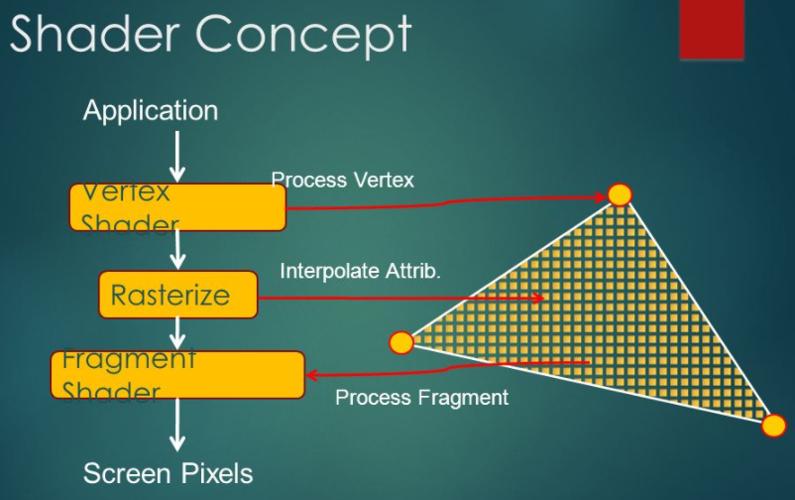

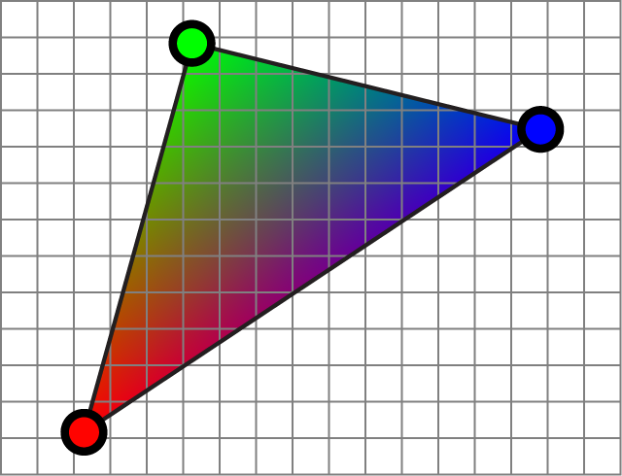

#### Todo #3 Write a function to compile a shader

Start by copying and pasting the following function above *updateAndRender*.

|  |
| --- |
| function createCompiledShader(shaderText, shaderType) {  var shader = gl.[createShader](https://developer.mozilla.org/en-US/docs/Web/API/WebGLRenderingContext/createShader)(shaderType);  gl.[shaderSource](https://developer.mozilla.org/en-US/docs/Web/API/WebGLRenderingContext/shaderSource)(/* todo arg1*/, /*todo arg2*/);  gl.[compileShader](https://developer.mozilla.org/en-US/docs/Web/API/WebGLRenderingContext/compileShader)(/*todo arg1*/);  if (!gl.[getShaderParameter](https://developer.mozilla.org/en-US/docs/Web/API/WebGLRenderingContext/getShaderParameter)(shader, gl.COMPILE_STATUS)) {  alert(gl.[getShaderInfoLog](https://developer.mozilla.org/en-US/docs/Web/API/WebGLRenderingContext/getShaderInfoLog)(shader));  console.log(gl.[getShaderInfoLog](https://developer.mozilla.org/en-US/docs/Web/API/WebGLRenderingContext/getShaderInfoLog)(shader));  return null;  }  return shader;  } |

This function is mostly written for you. It is meant to take in the raw text of a particular shader’s code along with a special value that specifies what type of shader it is (“shaderType” which should be either gl.VERTEX_SHADER or gl.FRAMENT_SHADER), compile it, and return the compiled result.

Your job is to understand what the code is doing and **fill in the missing function arguments**. Consult the [blue book](http://uniguld.dk/wp-content/guld/DTU/webgrafik//0321902920_WebGL.pdf) or [google](https://www.google.com/search?q=gl.shaderSource&oq=gl.shaderSource&aqs=chrome..69i57j0l5.479j0j7&sourceid=chrome&ie=UTF-8). There is nothing to verify the correctness of what you do here yet, but if in doubt feel free to ask your instructor or TA.

#### Todo #4 Compile Shaders

The initial version of the shaders has been written for you. Your next job will be to access the raw source code text that you pasted earlier, create a compiled version of that code, and then link it into a combined “program”. The following lines will grab the text and create a compiled version of each shader. As before, **you will need to fill in correct id to fetch the data**.

|  |
| --- |
| function createShaders() {  // Get the objects representing individual shaders  // todo get access to the shader source code text and compile  var vertexShaderText = document.getElementById(/* todo - choose the correct id*/).textContent;  var vertexShader = createCompiledShader(vertexShaderText, gl.VERTEX_SHADER);  var fragmentShaderText = document.getElementById(/* todo - choose the correct id*/).textContent;  var fragmentShader = createCompiledShader(fragmentShaderText, gl.FRAGMENT_SHADER);  } |

Try running your code again here. If there is a problem with shader compilation, it will be reported in your console and as an alert in the window.

#### Todo #5 Link Shader Program

Both of your shaders are meant to work together at different parts of the pipeline for rendering a single object at a time. For instance, when we render a triangle, first the vertex shader will execute for all of its vertices and later, the fragment shader will run for pixels that lie within the triangle on the screen. In order to specify that they are part of complete package where one is meant to follow the other, we have to bundle them in a “program”. Fill in the functions below with the correct arguments.

|  |
| --- |
| // Create an empty gl "program" which will be composed of shaders  shaderProgram = gl.[createProgram](https://developer.mozilla.org/en-US/docs/Web/API/WebGLRenderingContext/createProgram)();  gl.[attachShader](https://developer.mozilla.org/en-US/docs/Web/API/WebGLRenderingContext/attachShader)(shaderProgram, /* todo - arg2*/);  gl.[attachShader](https://developer.mozilla.org/en-US/docs/Web/API/WebGLRenderingContext/attachShader)(shaderProgram, /* todo - arg2*/);  // Tell gl it's ready to go, link it  gl.[linkProgram](https://developer.mozilla.org/en-US/docs/Web/API/WebGLRenderingContext/linkProgram)(/*todo arg1*/);  if (!gl.[getProgramParameter](https://developer.mozilla.org/en-US/docs/Web/API/WebGLRenderingContext/getProgramParameter)(shaderProgram, gl.LINK_STATUS)) {  alert("Could not initialise shaders");  } |

**Run it once again and verify that no errors have occurred.**

## Geometry & Buffers (what to render)

Part of what allows graphics processing to be fast is the dedicated GPU related hardware. The GPU has its own set of local memory that is completely separate from the RAM you are already familiar with on the CPU side (clearly visible on your motherboard). Graphics APIs like WebGL provide a way for you to allocate and fill the memory on the GPU side (inside the graphics card) so that operations can be carried out as fast as possible. To do this, noteo the following steps.

Pay close attention to the images which depict the current state inside WebGL. See chapter 3 of the [WebGL Programming Guide](http://uniguld.dk/wp-content/guld/DTU/webgrafik//0321902920_WebGL.pdf) for more detail. Below is an overview of the steps you will take along with visuals of how the WebGL state is affected.

1. Creating a buffer. (allocate memory on video card)

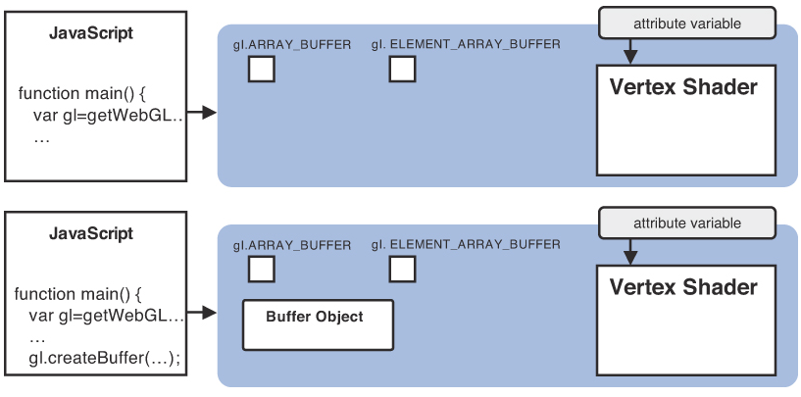

var vertexBuffer = gl.createBuffer();

1. Binding the buffer (WebGL is now pointing to your buffer). WebGL commands do different things based on what “state” the API is in. Binding a buffer let’s future commands implicitly know what buffer they should use without passing the buffer in as an argument to it.

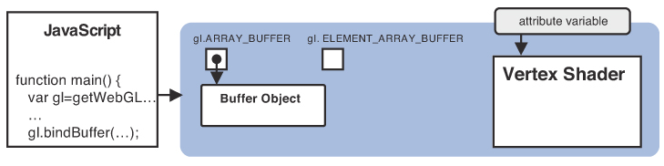

gl.bindBuffer(gl.ARRAY_BUFFER, vertexBuffer);

1. Buffering the data (moving your data from application-land to graphics-land). This command will take the data that you have available on the CPU side and move it into the currently bound buffer on the GPU side.

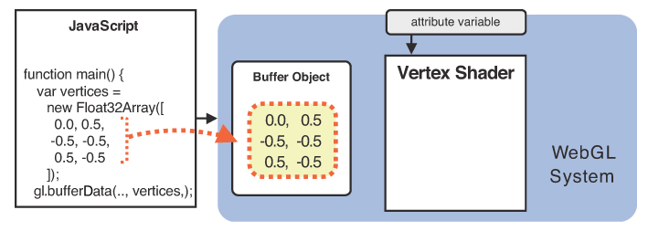

gl.bufferData(gl.ARRAY_BUFFER, vertices, gl.STATIC_DRAW);

1. Assign the buffer to attributes which will be used to actually render. A buffer is just a chunk of memory. It doesn’t specify what the data in the chunk means. Generally, the data we put into these buffers have multiple types of things like vertex position, normals, colors, etc… This function allows us to tell WebGL how to map the data that is nested inside the chunk.

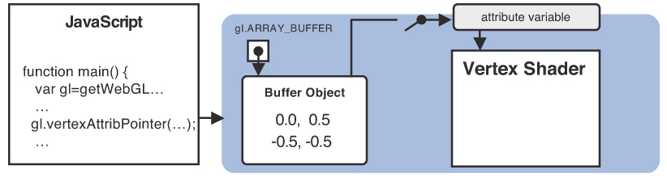

gl.vertexAttribPointer(a_Position, 2, gl.FLOAT, false, 0, 0);

In this trivial example, the buffer only contains 2d positions. We will also add color into the mix with this lab and get into the details of it then. This will allow the vertex shader to access each type of data in your buffer.

1. Enable (turn on) the vertex attribute that you just assigned

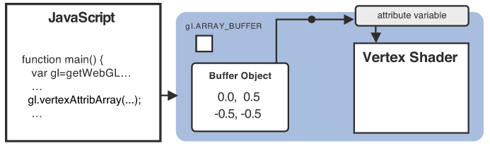

gl.enableVertexAttribArray(a_Position);

#### Creating and Filling the Position Buffer

First to make it easier to keep track of everything we have created a custom Javascript object that contains data related to the triangle geometry. It is at the top of the file and looks like this:

|  |
| --- |
| var triangleGeometry = {  // The core elements that we will need to render this object  worldMatrix: null, // the matrix that transforms this object from local space to world space  shaderProgram: null, // the shader program of "how" to render this object (vertex & fragment)  positionBuffer: null, // the buffer that holds all of the data associated with a vertex position  colorBuffer: null, // the buffer that holds all of the data associated with a vertex color  bufferItemCount: 3, // how many vertices the buffer contains  }; |

Next, take a look at the function *createTriangleGeometry* that takes no arguments. Inside this function we are going to do the following:

1. WebGL: create a new buffer
2. WebGL: “bind” the buffer (make it the current “thing” in the WebGL associated state)
3. Javascript: create an array of positions (3 floats each)
4. WebGL: send our array of vertices to the GPU

For this first buffer, the code is done for you but pay attention to what is happening because you will be responsible for implementing the next one.

|  |
| --- |
| // create the position and color information for this object and send it to the GPU  var newBuffer = gl.[createBuffer](https://developer.mozilla.org/en-US/docs/Web/API/WebGLRenderingContext/createBuffer)();  gl.[bindBuffer](https://developer.mozilla.org/en-US/docs/Web/API/WebGLRenderingContext/bindBuffer)(gl.ARRAY_BUFFER, newBuffer);  var vertices = [  0.0, 1.0, 0.0, // (vertex 1: x, y, z)  -1.0, -1.0, 0.0, // (vertex 2: x, y, z)  1.0, -1.0, 0.0, // (vertex 3: x, y, z)  ];  gl.[bufferData](https://developer.mozilla.org/en-US/docs/Web/API/WebGLRenderingContext/bufferData)(gl.ARRAY_BUFFER, new Float32Array(vertices), gl.STATIC_DRAW); |

This sets things up on the WebGL side of things. In order to render this later we’ll want to keep track of a few more things. Remember the *triangleGeometry* Javascript object we made right before this? Now, it’s time to fill it in (all of this inside of createTriangleGeometry). Note that this part is just for our own “book-keeping” and does not interact with WebGL.

1. First, we will create a matrix to be used only this object so that we can transform its vertices independently of any other object (will become the world matrix when applied).

|  |
| --- |
| // allocate a matrix that we will reuse for this object  triangleGeometry.worldMatrix = new Matrix4(); |

1. Next, we store which shader program we intend to use with this object.

|  |
| --- |
| // specify the shaders which carries the instructions for "how" to render  triangleGeometry.shaderProgram = shaderProgram; |

1. We should also remember the buffer that we just created and keep a reference.

|  |
| --- |
| triangleGeometry.positionBuffer = newBuffer; |

#### Todo #6 Create and Fill the Color Buffer

Inside of the TriangleGeometry function, repeat the process that we just saw for creating the position buffer only this one will be used for color. It should consist of 3 colors (9 floats). Each color is composed of 3 color channels (RGB) ranging from 0 to 1. The first color should be red, the second green, and the third blue. Make sure to store a reference to this new buffer on the triangleGeometry object as shown below.

|  |
| --- |
| triangleGeometry.colorBuffer = newColorBuffer; |

Nothing new will appear on the screen at this point. We have created something that we can draw, but we’re not actually doing the drawing yet. **Open your console in Chrome and make sure that no strange errors are appearing.**

#### Getting References to Vertex Shader Attributes

In order to actually process the data in our vertex buffer, we will need to make sure that it becomes available in the vertex shader through variables that we define.

Recall that we made 2 different vertex buffers for our object data: positions and color. Generally, each of these different **components of a vertex** are known in WebGL as “**attributes**”. So we have a position attribute and a color attribute.

Take a look at the code for our vertex shader:

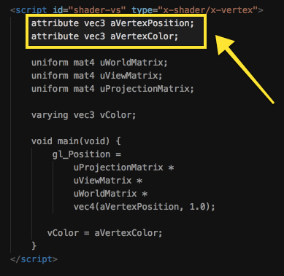

The shader defines 2 variables prefixed with the “attribute” keyword, both of type vec3 (this is similar to Vector3 that we created only this is a built-in in the shader language GLSL). Notice they match with the types of data in our vertex buffers (3 float position and 3 float color). Unfortunately, WebGL doesn’t know that and we must explicitly tell it to map our data to those variables.

Earlier we did the following:

1. Acquired the shader source code as text and compiled it
2. Created a shader program and attached our compiled shaders to it
3. Linked our shader program to get its final state (compatible set of vertex and fragment shaders)

That got our shaders ready to use but they’re still not connect to the data in our vertex buffer in any way. We need to get references to the variables inside the shader in order to make that happen. We do this using the following:

|  |
| --- |
| // Make sure the WebGL state knows this is the program we're working with  gl.[useProgram](https://developer.mozilla.org/en-US/docs/Web/API/WebGLRenderingContext/useProgram)(shaderProgram);  // Get a reference to the attribute "aVertexPosition"  shaderProgram.vertexPositionAttribute = gl.getAttribLocation(shaderProgram, "aVertexPosition");  // Turn on this attribute  gl.[enableVertexAttribArray](https://developer.mozilla.org/en-US/docs/Web/API/WebGLRenderingContext/enableVertexAttribArray)(shaderProgram.vertexPositionAttribute);  // Do the same thing for our other piece of data (1d color)  shaderProgram.vertexColorAttribute = gl.[getAttribLocation](https://developer.mozilla.org/en-US/docs/Web/API/WebGLRenderingContext/getAttribLocation)(shaderProgram, "aVertexColor");  gl.[enableVertexAttribArray](https://developer.mozilla.org/en-US/docs/Web/API/WebGLRenderingContext/enableVertexAttribArray)(shaderProgram.vertexColorAttribute); |

The [*getAttribLocation*](https://developer.mozilla.org/en-US/docs/Web/API/WebGLRenderingContext/getAttribLocation) will get us a reference to the variable on the shader program with the name given in quotes.

In the code above, we are using the abusive power of Javascript to create new variables on the shaderProgram object to store the reference. That object doesn’t store these things by default, we simply created those variables on the existing *shaderProgram* object because it was convenient. If this idea is confusing, please ask me to clarify as it will help you better understand Javascript.

To further clarify, being an “attribute” means to be a part of a vertex. Another way to think about a vertex is as being all of the data that is specified along with a particular position. The vertices we specify for this assignment have only 1 additional attribute: color. However, many extra pieces of data can also be grouped with the positions. Typical examples are the normal vector and texture coordinate (which we will discuss later).

#### Getting References to Vertex Shader Uniforms

In addition to the attributes, it is also necessary to be able to render using additional data that stays constant (doesn’t change per vertex) and is not part of a vertex.

For instance, when we draw a triangle, we execute the vertex shader once for each vertex (3 times). The vertex shader is responsible for the geometric transformation; taking the position part of the vertex from its local object space to projection space (clip space). This requires the shader to know about the matrices (world, view, projection) used which **DO NOT** **change** while this object is being rendered. Each vertex position will be transformed by **the same matrices**.

Shader variables that stays constant for every run of the shader on a single object are called “uniforms”. Contrast this with “attribute” variables which will be different for every run of the vertex shader because each run operates on a different vertex.

We do the same as before except this time we will get references to our uniforms.

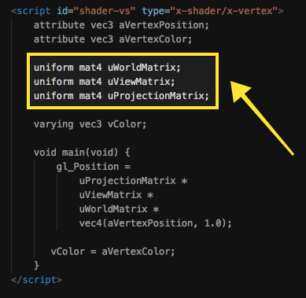

Much like we used *gl.*[*getAttribLocation*](https://developer.mozilla.org/en-US/docs/Web/API/WebGLRenderingContext/getAttribLocation) before, this time we use *gl.*[*getUniformLocation*](https://developer.mozilla.org/en-US/docs/Web/API/WebGLRenderingContext/getUniformLocation).

We store references in the following places:

|  |
| --- |
| *shaderProgram.worldMatrixUniform*  *shaderProgram.viewMatrixUniform*  *shaderProgram.projectionMatrixUniform* |

## 

## 

## 

## 

## Rendering (issuing commands)

Inside the *renderTriangle* function we will be doing the following (next todo):

1. Specify where this object is in the world (set values on its world matrix)
2. Send the world, view, and projection matrices to the shader (via uniforms)
3. Bind the triangle’s buffers (tell WebGL what we are going to be working with)
4. Tell WebGL how to map the position part of the vertex buffer to the shader
5. Tell WebGL how to map the color part of the vertex buffer to the shader
6. Submit the draw call

#### Todo #7 Render the Triangle: Matrices

We will not be manipulating the camera (view) for this assignment so we can assume that it is at its default location: the origin. In WebGL the basis vectors for view space will be such that x is to the right, y is up, and z is pointing backwards or out of the screen. That means that -z is forward.

Now is the point where we start to use all of the information that we are conveniently storing on the *triangleGeometry* Javascript object, starting with *triangleGeometry.worldMatrix*. Perform the following 2 operations:

1. **Reset the matrix back to identity (we don’t want previous values to affect this render)**
2. **Make it a translation in the -z direction of (0, 0, -7)**

The view and projection matrices are transforms that are associated with the camera and independent of any one object. However, for now we will set them here.

The view matrix will remain unchanged but if you want to be extra careful, you could reset it to identity.

Unlike our default view (identity), the perspective projection matrix must be set. Use the *setPerspective* function that is a part of Matrix4. It takes 4 arguments consisting of vertical field of view, aspect ratio, near plane distance, and far plane distance.

**Set the global variable *projectionMatrix* using the following values:**

**Vertical FOV: 45 degrees**

**Near plane distance: 0.1**

**Far plane distance: 1000**

You will need to **compute the aspect ratio** yourself based on the width and height of the canvas.

At this point we’ve got our matrices in the correct form, they will be sent to send to the shader using the code below.

|  |
| --- |
| // Send our matrices to the shader  gl.[uniformMatrix4fv](https://developer.mozilla.org/en-US/docs/Web/API/WebGLRenderingContext/uniformMatrix)(shaderProgram.worldMatrixUniform, false, triangleGeometry.worldMatrix.clone().transpose().elements);  gl.[uniformMatrix4fv](https://developer.mozilla.org/en-US/docs/Web/API/WebGLRenderingContext/uniformMatrix)(shaderProgram.viewMatrixUniform, false, viewMatrix.clone().transpose().elements);  gl.[uniformMatrix4fv](https://developer.mozilla.org/en-US/docs/Web/API/WebGLRenderingContext/uniformMatrix)(shaderProgram.projectionMatrixUniform, false, projectionMatrix.clone().transpose().elements); |

The [*uniformMatrix4fv*](https://developer.mozilla.org/en-US/docs/Web/API/WebGLRenderingContext/uniformMatrix) function will take the float array from our Matrix4 object and send it to the corresponding uniform variable in our shader. There is one oddity to point out here. Notice the call to clone() and transpose(). For simplicity, we previously coded our matrix from a row first perspective like this:

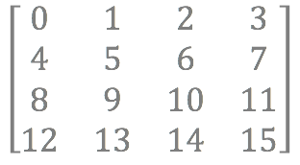

For performance reasons, WebGL actually wants it in the following order:

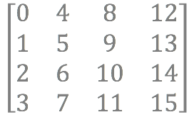

This is the reason for the transpose. The clone is there to make sure that we don’t change the original matrix via the transpose. It’s not ideal but we are not worried about the performance cost here. It is fine for toy applications like this.

Next we let WebGL know which vertex buffer we’re working with by “binding” it again. That way, when we call the functions in the next todo below, it will apply to the correct object/buffer. Recall how we did the bind the first time? The variable was called “newBuffer” but we no longer have access to that variable. The important thing is that we bind whatever variable holds the reference to the buffer (newBuffer had a reference temporarily).

#### Todo #8 Render the Triangle: Map the Vertex Buffers to Shader Attribute

Here’s the part where all of that earlier bookkeeping we did pays off. In order to start processing our vertices in the vertex shader, WebGL needs to know how to carve up the data we have such that each piece corresponds to an attribute variable in the vertex shader. When the vertex shader executes for each vertex, those attribute values will contain the matching information for that particular vertex. We will perform this mapping using the function [*vertexAttribPointer*](https://developer.mozilla.org/en-US/docs/Web/API/WebGLRenderingContext/vertexAttribPointer). Here is its function signature:

|  |
| --- |
| void gl.[vertexAttribPointer](https://developer.mozilla.org/en-US/docs/Web/API/WebGLRenderingContext/vertexAttribPointer)(index, size, type, normalized, stride, offset); |

And here is how we map the vertex buffer to the matching attribute variable “aVertexPosition”:

|  |
| --- |
| gl.[vertexAttribPointer](https://developer.mozilla.org/en-US/docs/Web/API/WebGLRenderingContext/vertexAttribPointer)(  triangleGeometry.shaderProgram.vertexPositionAttribute, // a reference to the attribute on the shader  3, // number of floats  gl.FLOAT, // type is float  gl.FALSE, // ignore  0, // stride - used for mixing data in a single buffer, ignore  0 // offset - used for mixing data in a single buffer, ignore  ); |

You will need to call this function for every vertex attribute that we have. In our case, we have 2: position and color. Using the code above as an example, **call the same function again** with the correct arguments to map the 3D color vertex attribute.

|  |
| --- |
| gl.[vertexAttribPointer](https://developer.mozilla.org/en-US/docs/Web/API/WebGLRenderingContext/vertexAttribPointer)(  /* todo for colorAttribute */  ); |

#### Rendering the Triangle: Issue Draw Call

Enough teasing, let’s get this thing on the screen. Issue the draw call as follows:

|  |
| --- |
| gl.[drawArrays](https://developer.mozilla.org/en-US/docs/Web/API/WebGLRenderingContext/drawArrays)(gl.TRIANGLES, 0, triangleGeometry.bufferItemCount); |

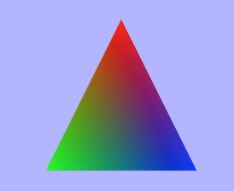

So what was your time to first triangle? :)

Congratulations, if you’ve made it this far then the hardest part is behind you (IMO).

## Rotating the Triangle

#### Todo #9 Rotation: Quick & Dirty

For the moment, let’s ignore the timing aspect of generating a rotation that animates smoothly over time and just get something working. At the beginning of the *renderTriangle* function we set up our triangle’s world matrix. First we cleared it to identity and then we translated it. We will also want our triangle to rotate about its origin and not (0, 0, -7) so make sure to apply your rotation before the translation. I recommend using the *setRotationY* function on your Matrix4 object. However, note that *setRotationY* will overwrite everything in your matrix (not multiply anything).

To create an animation, the rotation should increase every frame. Now, every time your *renderTriangle* function is called, increment that value that is passed to the function *secondsElapsedSinceStart* and use the computed degrees value to create the rotation.

When you run, the **triangle should be rotating now**.



## Adding the Line Grid

A triangle by itself doesn’t do a good job of helping us judge space or see the effects of perspective. If we were to start moving the camera around at this point it would be easy to get a lost once the triangle is no longer in sight (you’d only see blue even though your position and orientation would be changing).

To alleviate this, we will draw grid line similar to the way 3Blue1Brown does but only for the horizontal xz plane like so:

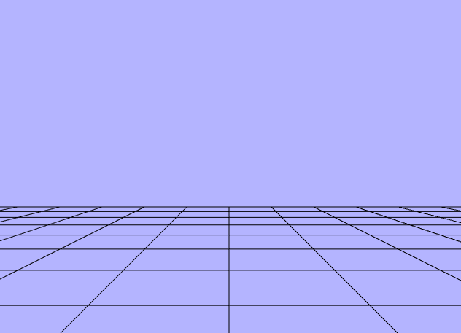

#### Todo #10 Create the Line Grid Data

Similar to how we created the triangle, we will create a grid made up of criss-crossing lines. There will be 21 going across and 21 going back and forward. Here is the part for you to fill out in *createLineGridBuffer*:

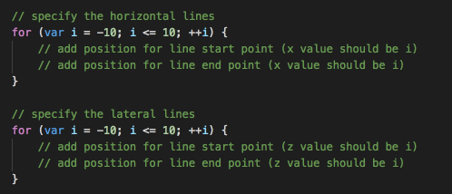

The rest follows the same sequence of operations as we did with the triangle earlier with the exception being that we’re creating **pairs** of vertices as lines rather than **triplets** as triangles.

#### Todo #11 Render the Line Grid

This will be very similar to rendering the triangle only now you must add the code. See the *renderLines()* and fill it in as appropriate. You should get something like this:



You might notice something that doesn’t quite match: lines draw over your triangle instead of respecting depth as we described when going over the z-buffer algorithm. That’s because the depth test (which uses the z-buffer) needs to be enabled. Oddly, it’s off by default. Somewhere in your initialization code add the following:

|  |
| --- |
| gl.enable(gl.DEPTH_TEST); |

## Bonus

#### Todo #1 Time-Based Rotation (+5 points)

Change the rotation of the triangle such that it’s speed can be specified in degrees of rotation per second rather than some arbitrary number that is tied to frame rate.

Currently if our frame rate changes, it will affect the speed at which the triangle rotates. Every worthwhile simulation must account for time.

You can get the current time as follows:

|  |
| --- |
| var currentFrameTime = new [Date](https://developer.mozilla.org/en-US/docs/Web/JavaScript/Reference/Global_Objects/Date)().[getTime](https://developer.mozilla.org/en-US/docs/Web/JavaScript/Reference/Global_Objects/Date/getTime)(); |

I recommend finding a way to get the time value as a number of seconds that have elapsed since the application began. Then, if you have a timer that ticks at a number value of 1 per second, you can treat it as seconds. Decide how many degrees per second you should have rotated and set your rotation matrix accordingly.

#### Todo #2 Scrolling Colors (+5 points)

Truth be told, writing fragment shader code is really fun. This bonus is about the joy of playing with the code. Simple things like messing with color can be delightful.

Currently the fragment shader takes the color that was interpolated from the color at each vertex and displays it directly. Instead, we would like our colors to animate based on time. To do this you will have add one extra uniform to your fragment shader (no need to declare this in the vertex shader).

|  |
| --- |
| uniform float uTime; |

Then you will have to do all of the legwork you originally did for the rest of your uniforms such that you get a reference to it in javascript and then update its value every frame.

Acquiring the reference will work in the same manner as before but pushing those values from Javascript to GLSL will be slightly different.

Before you used:

|  |
| --- |
| gl.uniformMatrix4fv(shaderProgram.worldMatrixUniform, false, /* a float array from a matrix */); |

To send a single float you will use something like the following:

|  |
| --- |
| gl.uniform1f(shaderProgram.timeUniform, secondsElapsedSinceStart); |

Now it’s up to you to use that constantly updating value of time along with your color to produce some more interesting results.

Note that colors above 1.0 will be capped so you will see no animation. You will need a function that maps your time value to something in the 0 to 1 range.

Here are some possible functions available in GLSL to help with that:

* [fract](https://www.khronos.org/registry/OpenGL-Refpages/gl4/html/fract.xhtml), [sin](https://www.khronos.org/registry/OpenGL-Refpages/gl4/html/sin.xhtml), [cos](https://www.khronos.org/registry/OpenGL-Refpages/gl4/html/cos.xhtml)

Here is my result using fract:

